PRESS INFORMATION
Groningen, The Netherlands, 15 November 2017
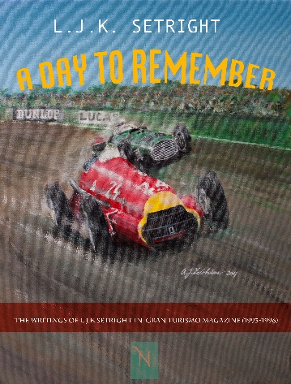

A day to remember, new (e-)book with writings of L.J.K. Setright

From 1993 to 1996 L.J.K. Setright contributed 10 articles to the Dutch car magazine GranTurismo. In these witty, erudite articles Setright, one of the 20th century's most influential motoring journalists, wrote about historic GP races, racing cars, contemporary cars, automotive history and the people in the automotive industry. Setright’s writings have to be savoured, they are not always easy to read (let’s call it an acquired taste), but anyone with a heart for the motoring scene will enjoy reading them, as Setright turned motoring into a romantic matter.
After the first article (after which this book was titled, A day to remember, about the British Grand Prix of 1951, won by Froilan Gonzales from Ferrari), the copy kept arriving in our offices every three months, ten writings in total.
Surely many people will enjoy reading them more than twenty years after they were originally published in Gran Turismo. Setright’s texts are very much like good wine or cigars, the older they get the better they become.
Nobelman Publishers has made an e-book of these writings of L.J.K. Setright. The text is, of course, the original text by mr. Setright, in English. Because of worldwide distribution we have decided to start with an e-book. It’s easier to sell worldwide, and above all cheaper than a paper version of the book would be. Depending on the interest from readers around the world we will consider publishing a hardback version of the book.

About the author:
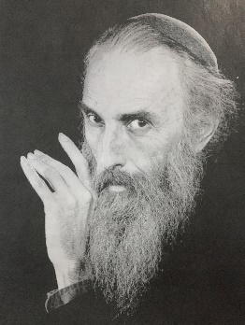L.J.K. Setright (1931 – 2005) was a renowned motoring journalist and author who wrote articles and books about motorcycles, cars and automotive engineering. His articles were published in several magazines, the British magazine Car being the most well-known. Between 1993 and 1996 he contributed to the Dutch car magazine Gran Turismo. The articles in this book are the result of those contributions. Setright's writing style was very erudite and considered to be slightly over the top by some (he didn’t hesitate to put Latin phrases through his reasonings). However, everybody agreed that his engineering knowledge was formidable. He had a strong enthusiasm for Bristol Cars and for Japanese engineering, especially Honda.
Setright was also known for his love of smoking tobacco, in particular Sobranie Black Russian cigarettes, and for his elegant sartorial style.
He spent the last 25 years of his life in London.
More information or a copy of the e-book (ePub) can be obtained from
Gerrit Brand, info@nobelman.nl
+ 31 6 50831893
Nobelman Publishers
Emdenweg 3
9723 TA Groningen
The Netherlands
www.nobelman.nl

